**CSC Pathways**

User Manual

Frontend website & Backend CMS

Michael Risher

June 27, 2017

Table of Contents

User Side of the Website 3

Navigating the user side 3

Possible problems 5

Accessing the administration side of the site 5

Problems logging in 6

Recovering a forgotten password 7

Managing Classes 8

Creating classes 8

Fields within the create class 9

Possible problems creating a class 11

Editing classes 11

Deleting classes 11

Managing Certificates 12

Creating certificates 12

Fields within the create certificate 14

Possible Errors 17

Editing certificates 19

Deleting certificates 20

Managing Users 20

Creating users 20

Editing a user 21

Recovering a password for a user 21

Deleting a user 22

# User Side of the Website

The user accessible side of the website consists of one page. From this single page, the user can see a listing of all the certificates available in a tree structure. From this listing, the user can click on any of the certificates to show more details about that specific certification, all while staying on the same page. The details for each certification include a brief description of the program, the expected learning outcome, and an outline of courses they should take and when we offer them. In the outline of courses, they can click on any course to show more details about that course such as the title, a brief description, any prerequisites, advisories, or corequisites, a transfer code if any, and the number of units.

## Navigating the user side

All navigation on the user side are simple. You start with a listing of all the certificates broken into three groups based on what class or classes you need to take. The site also provides the certificate number and total units required to complete the certificate. All the certificates in the listing are colored blue to provide clarity that these can be clicked.

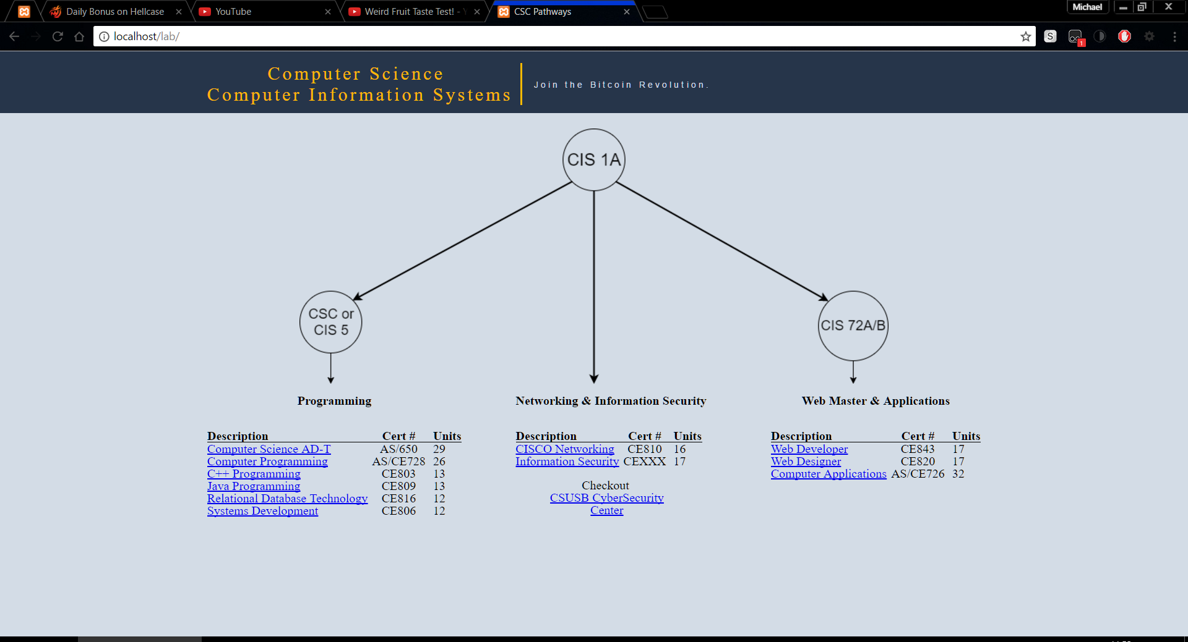

Figure 1 Image of what the user would see

Clicking on any of the blue certificates will request data on the certificate from the server. Once the data on the specific certification loads the page will scroll down to display it. Inside the certificate information it redisplays the certification title along with a brief description of the certificate, a listing of what you are expected to learn by completion of the certification, and a schedule of classes to take and when we offer them. In the schedule of classes that need to be taken each of the classes are linked to display information about that class, they are clearly marked blue to indicate they can be clicked. In the top right corner of the certificate information page there is an up arrow that will go to the top. There is also a tooltip to explain this to users when they hover over it.

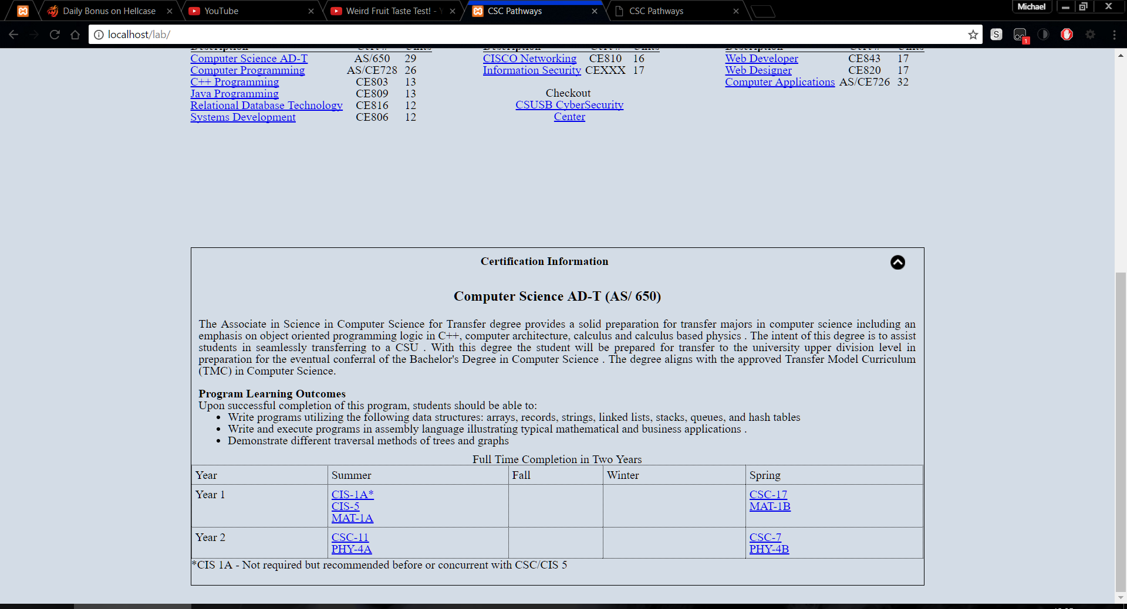

Figure 2 Certificate information as seen by user

After the user clicks on a class the page then loads that class data and displays it below the certificate information. In the class information box, there is the class title, an equivalent transfer code if any, any required classes to take this class, number of units, and a brief description. Like the certification information there is a to top image, however this goes to the certification instead of the top which is noted in a tooltip for the user.

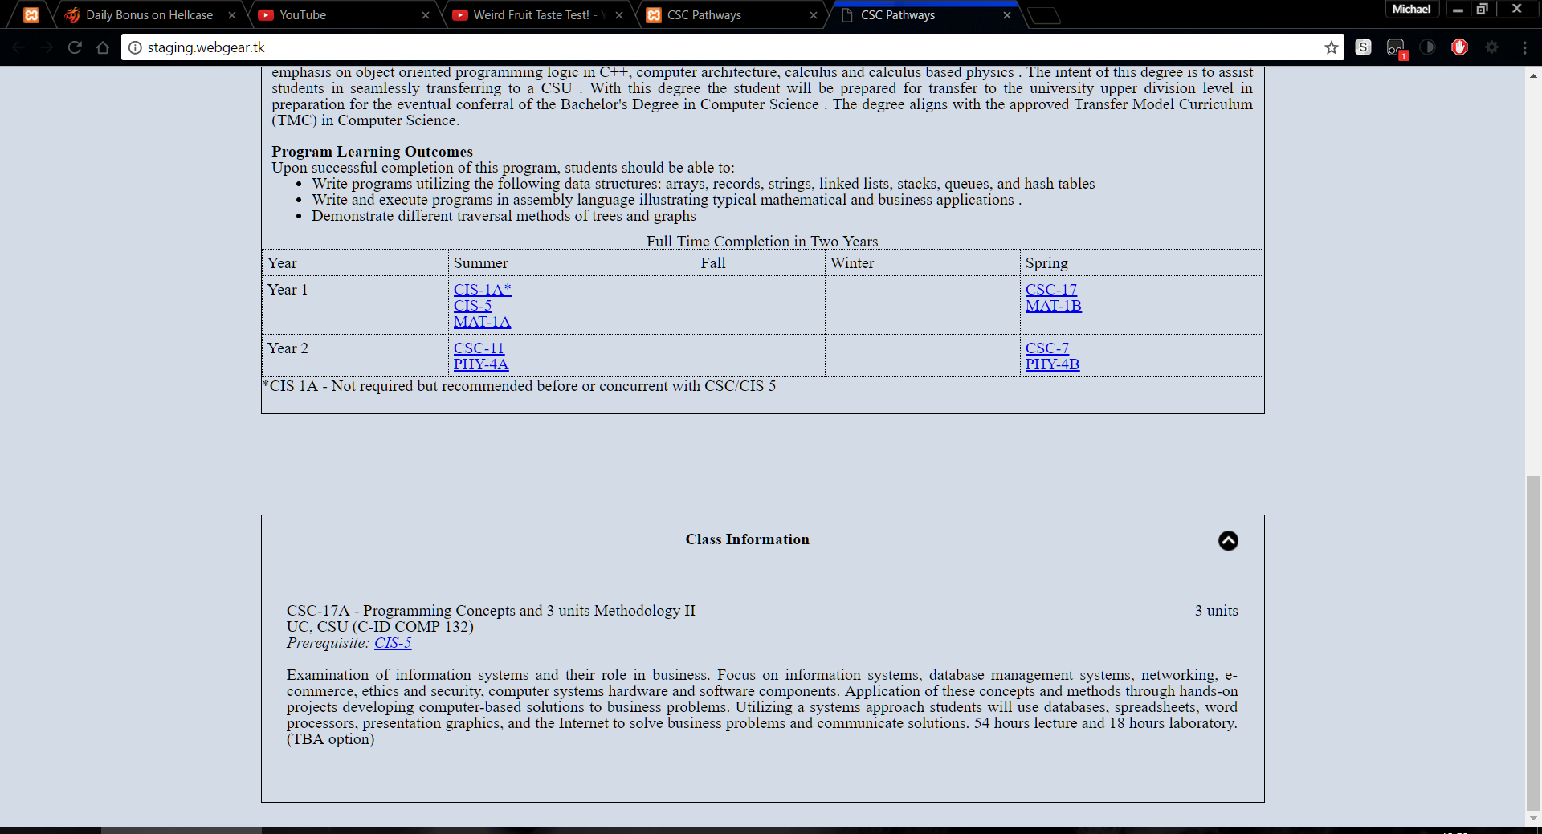

Figure 3 Class information as seen by the user

### Possible problems

The users could have a few problems. They would mostly be related to interrupted internet connections or a slow connection. If a user has a slow connection they would see a loading icon (Figure 4). If a user’s internet was interrupted the certificate or class information would fail to load and would then display that it failed to load (Figure 5). The errors can usually be resolved by reloading the page.

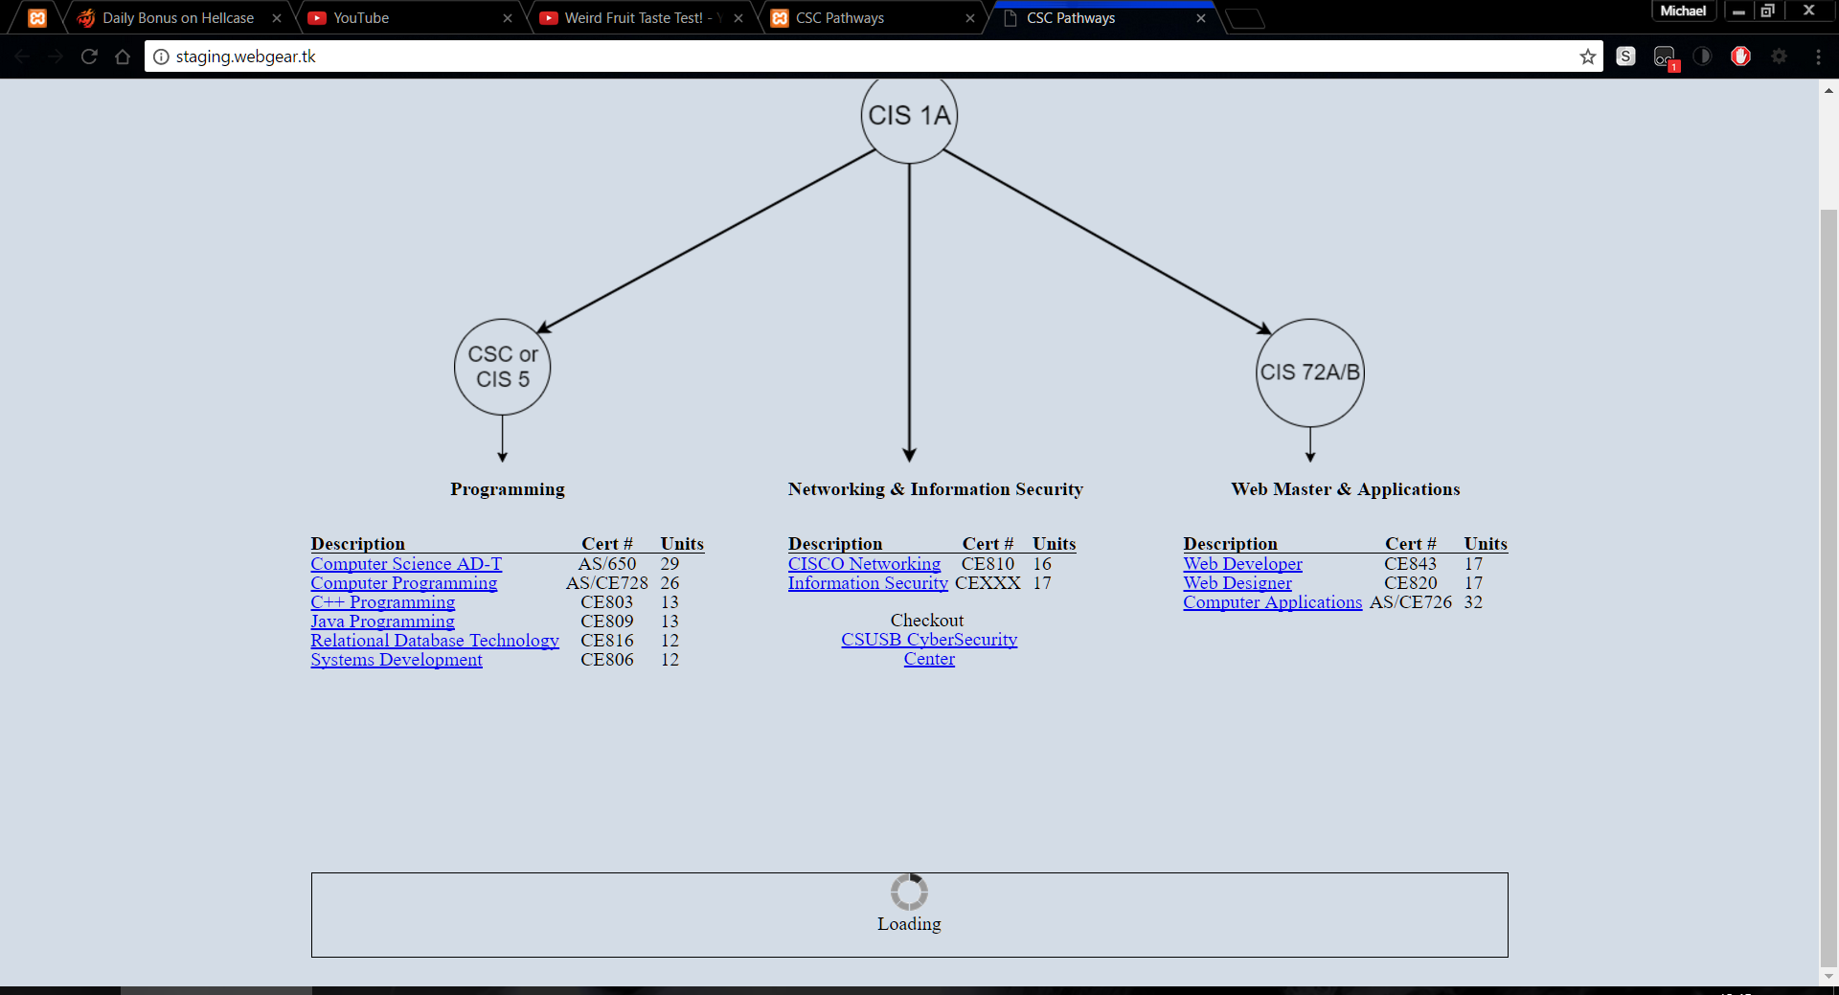

Figure 4 Displaying a slow internet

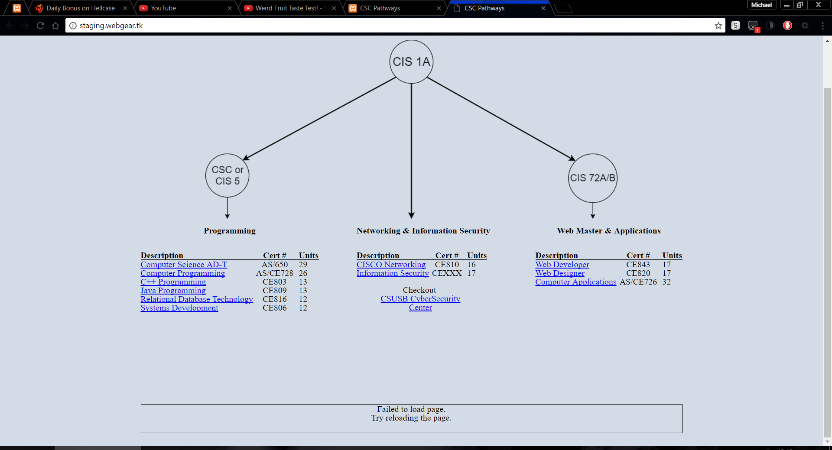

Figure 5 Displaying a failure to load error

# Accessing the administration side of the site

For security reasons, there is no public link to the administration side of the site. The link to the site is <http://cscpathways.us/login>. When you load the page, you will be presented with a form that has a field for a username and password.

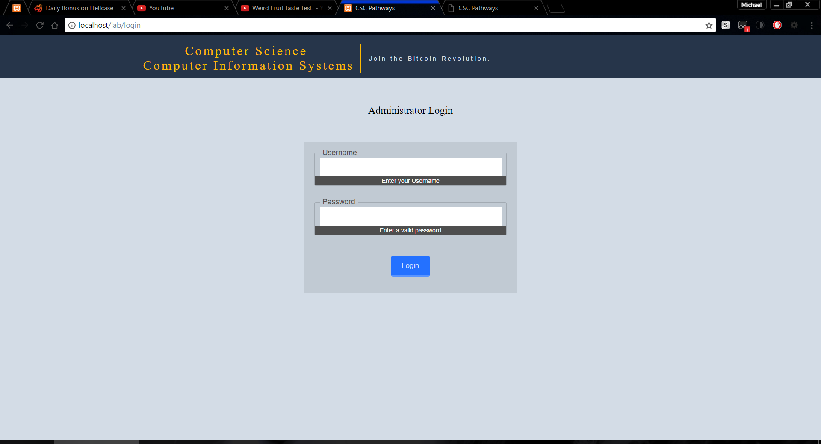

Figure 6 The administration log in page

To log in enter your correct username and password. After a successful log in you will be redirected to the admin homepage. In the admin homepage, you can click the orange title at the top of the page to get back to the user side of the site. Just below the orange line are links to go to the admin home (the page you are on currently), manage classes, manage certificates, manage users (if the current user has the rights to), and on the far right there is a link to logout of the administrative side.

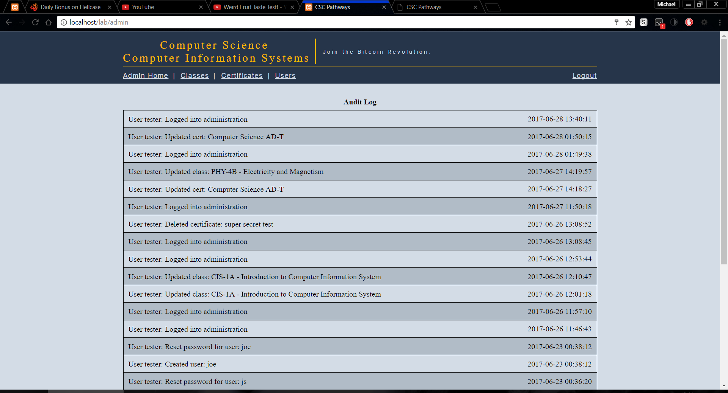

Figure 7 Admin home page

If the user is inactive for longer than 10 minutes the website will log you out. If you try to reload a page after 10 minutes you will be redirected to a 404 error and will have to go to <http://cscpathways.us/login> to log back into the administrative side of the site.

### Problems logging in

There are two problems that could occur while trying to log in. You enter your password or username incorrectly (Figure 8) or your account has been set to inactive by an administrator (Figure 9). If your account has been deactivated you can ask your administrator to reactivate you. If you have forgotten your username or password you can ask an administrator to recover your password.

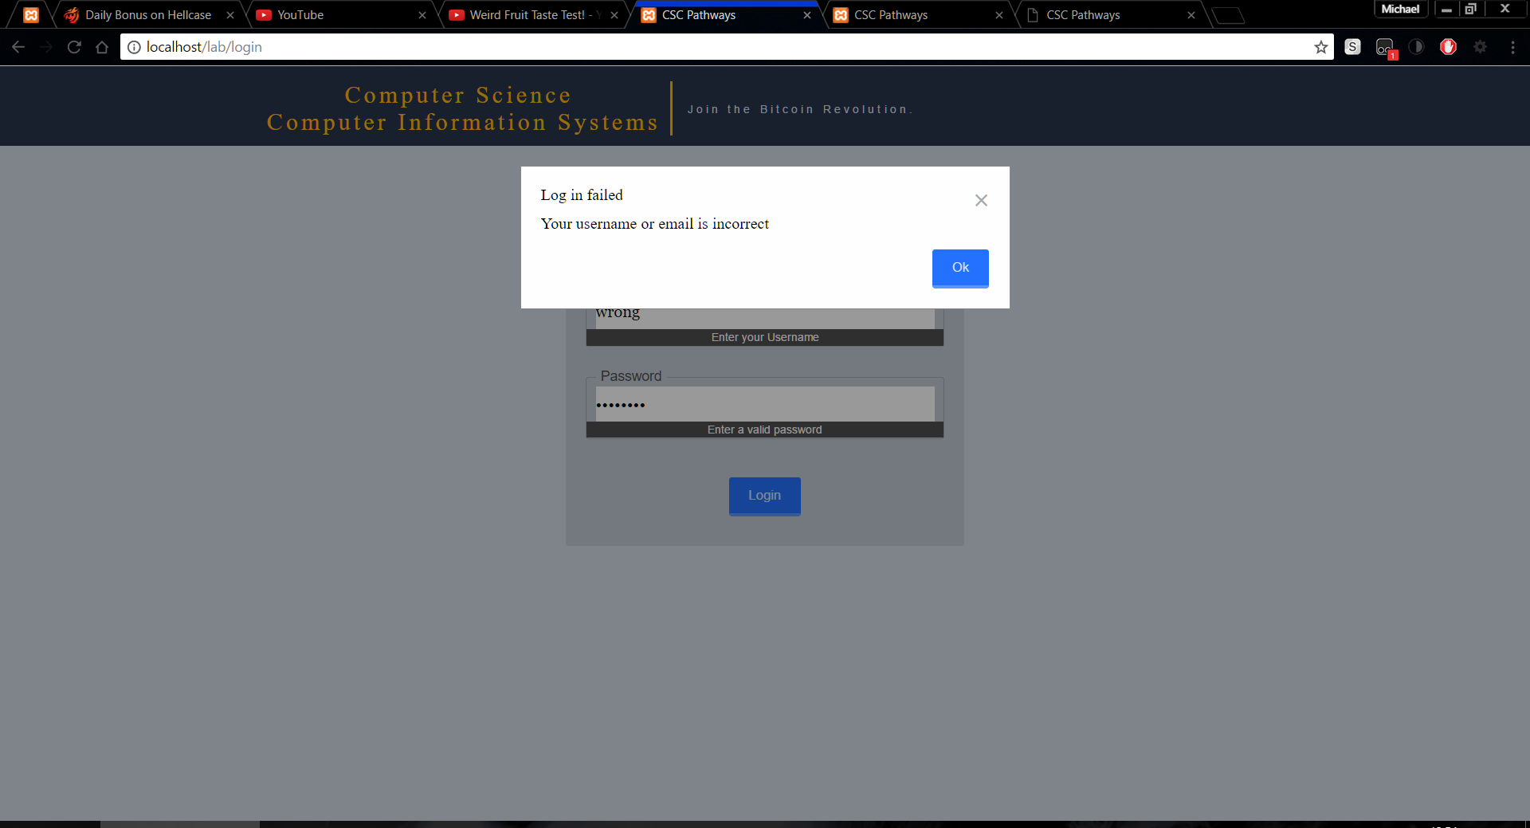

Figure 8 Incorrect username or password on log in page

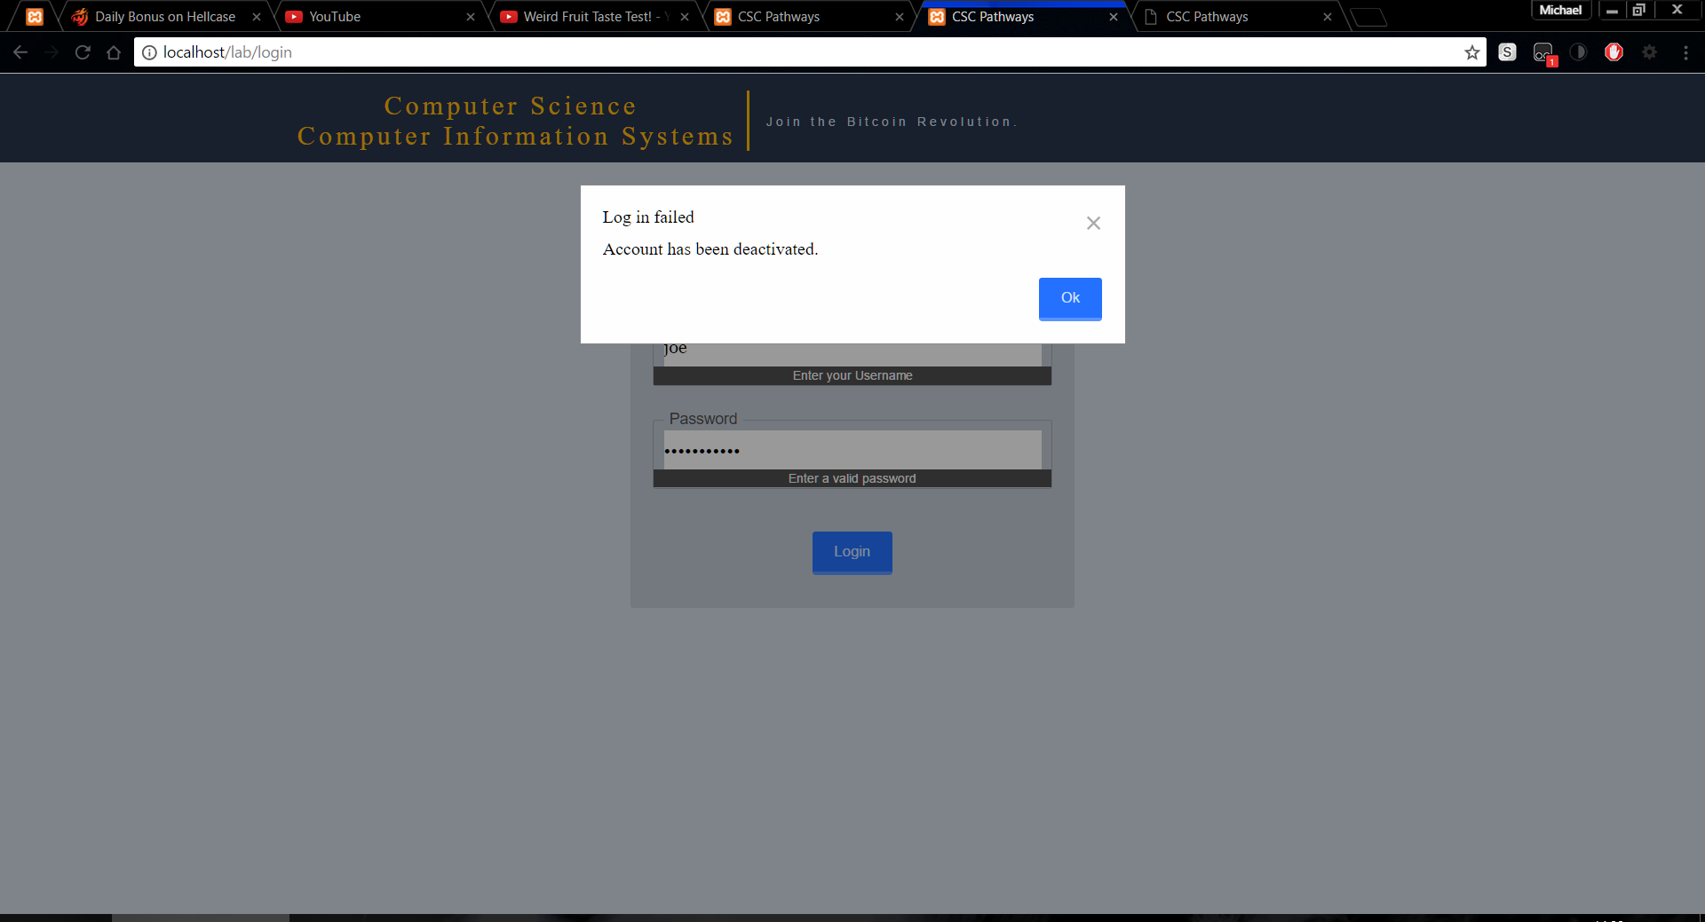

Figure 9 Deactivated user in log in page

### Recovering a forgotten password

After requesting a password recovery from an administrator, they will send you a link that looks something like this <http://cscpathways.us/users/resetPassword&token=eQevERDvb1RGCiu>. From this page, you will have to enter your username.

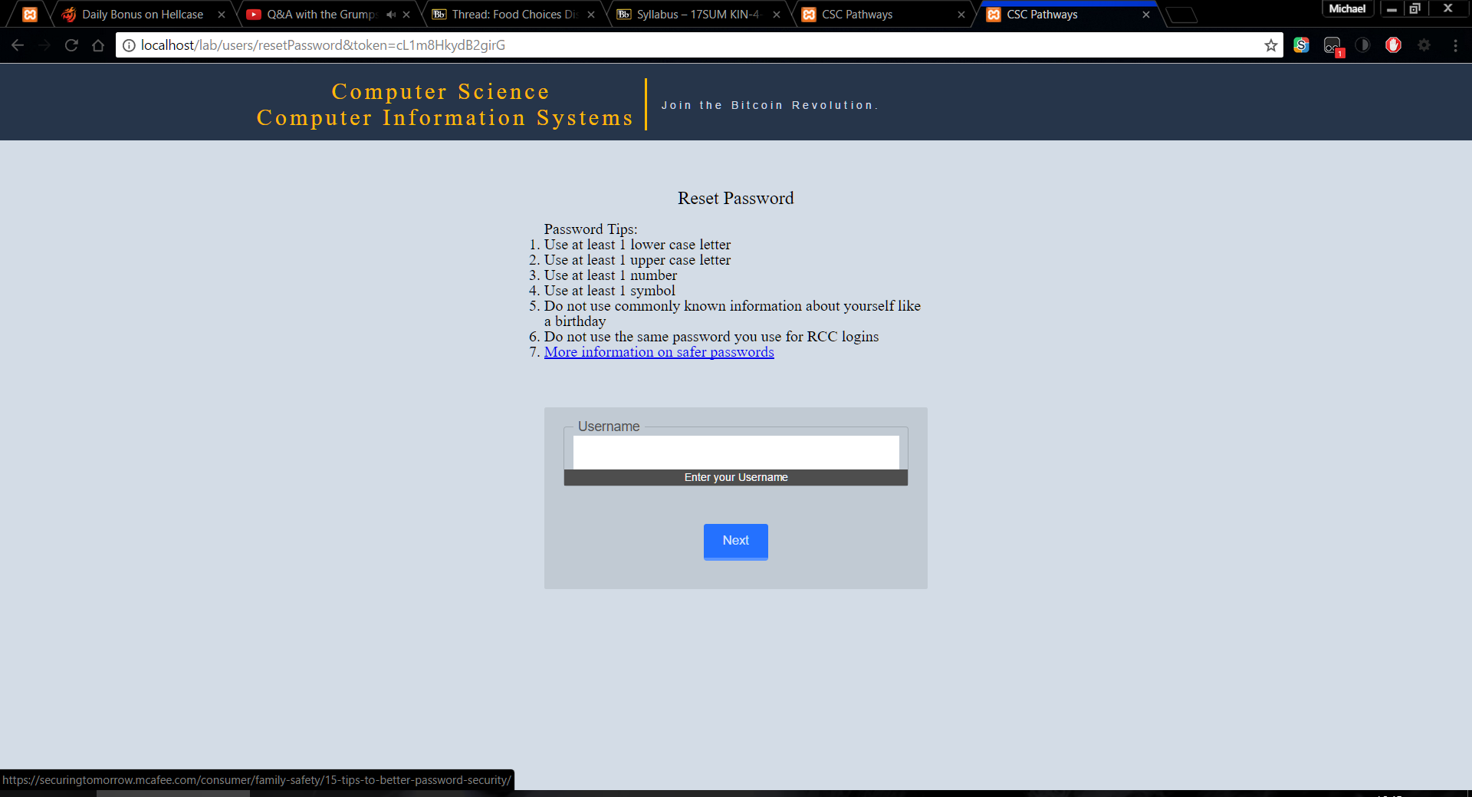

Figure 10 Reset password form asking for username

Once your username and token are authorized, it will then prompt you to enter your new password. This password must have at least one uppercase letter, lowercase letter, number, and symbol to be valid. Once you provide a valid password you will need to repeat the password right below.

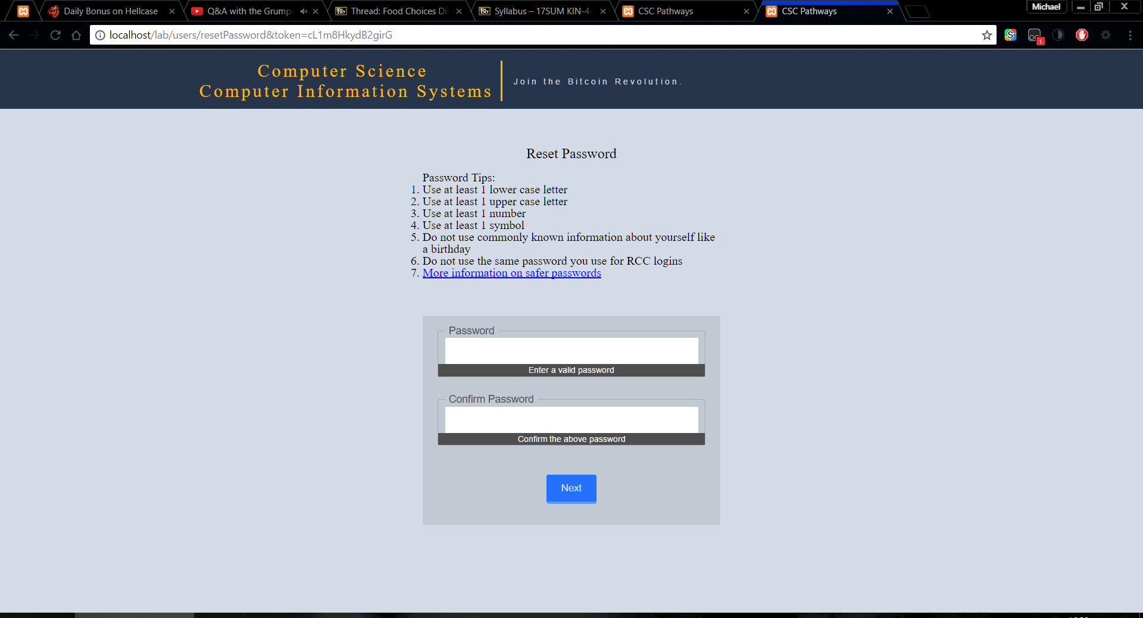

Figure 11 Reset password form asking for new password

After you have reset your password you will then be redirected to the log in page from there you can log in normally with your new password.

# Managing Classes

All the classes that appear in the class information box can be edited through the administrative side of the site. Managing classes can be accessed by the link tilted classes under the orange title. Here are the editable areas for a class as seen from the user homepage

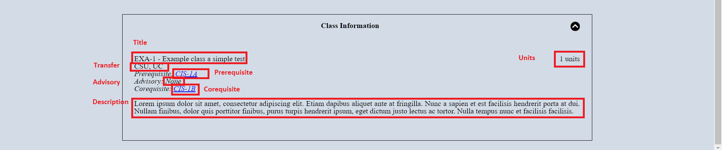

Figure 12 Showing the editable areas for a class

## Creating classes

To create a class, in the manage classes page, scroll down to the bottom of the page, and click the blue Create Class button

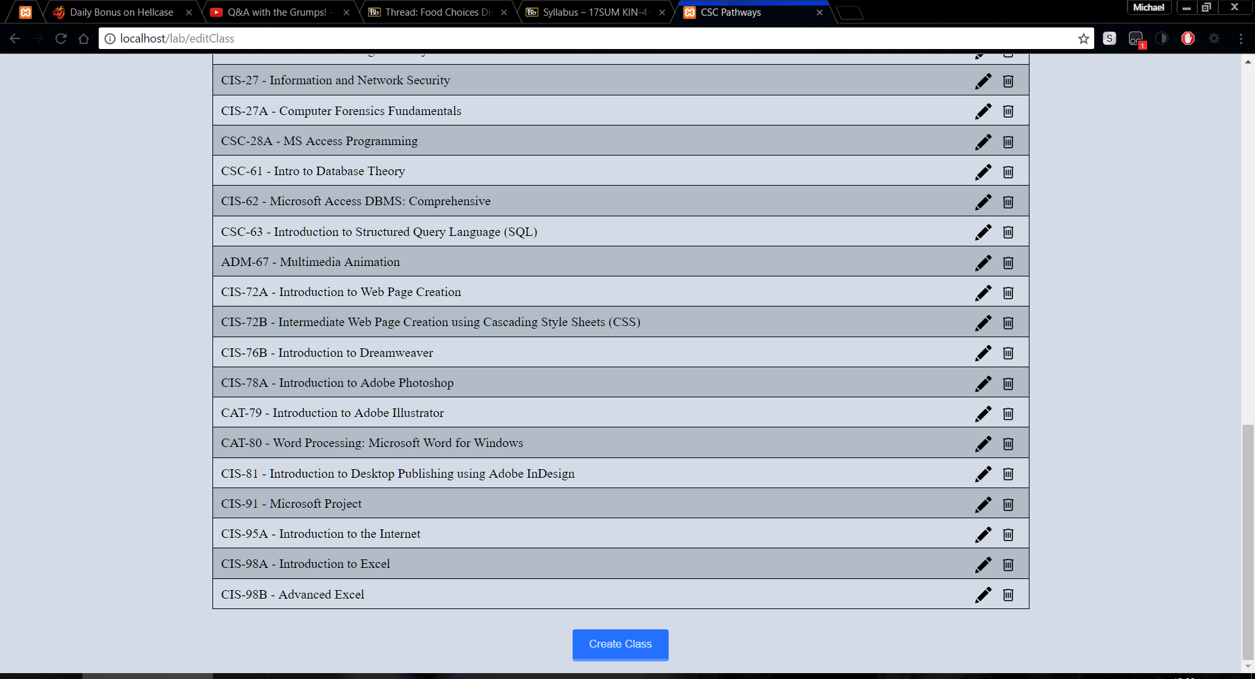

Figure 13 Create class button

That button will open in a window popup called a modal. Inside this modal is a form with all the inputs each class can have

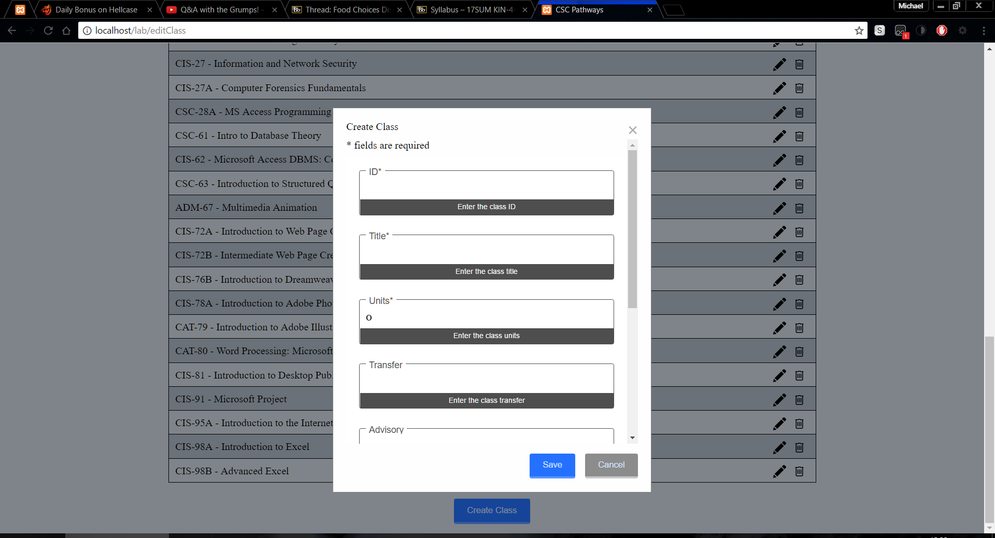

Figure 14 Create class form

There are four required fields in this form they are ID, title, units, and description. These four fields must have a value and units can only be a number. All other fields are optional and can be left blank. Now to explain each of the fields

### Fields within the create class

#### Id

ID is the class’s id used internally only. If the class was CIS-1A then the ID would be the first letter lowercased “c” and everything after the dash “c1a”. This field is required.

#### Title

Title is the class’s title for example CIS-1A – intro to computers. This title must match this pattern three letters (CIS) dash then some number (CIS-1) and optional a letter followed by a space dash space and then a title (CIS-1A - title). This field is required.

#### Units

Units is the number of units the class has. It can only be a number and the page should prevent you from doing anything but a number. This field is required.

#### Transfer

Transfer is any equivalent class code to a UC or a CSU. For example, UC, CSU (C-ID ITIS 120). This field is optional.

#### Adviosry, Prerequisite, Corequisite

Advisory, Prerequisite, Corequisite are classes that are advised to have taken prior to this class, classes you must take prior to this class, and classes that you need to take concurrently or prior to this class. Note that all three of these fields have a blue link to add class. If you want the class to be clickable on the user side of the website you need to use the add class link to properly link classes. Upon clicking the blue add class link a new modal will display. This modal will give you a dropdown of classes to pick from. Once you select the class click the add button.

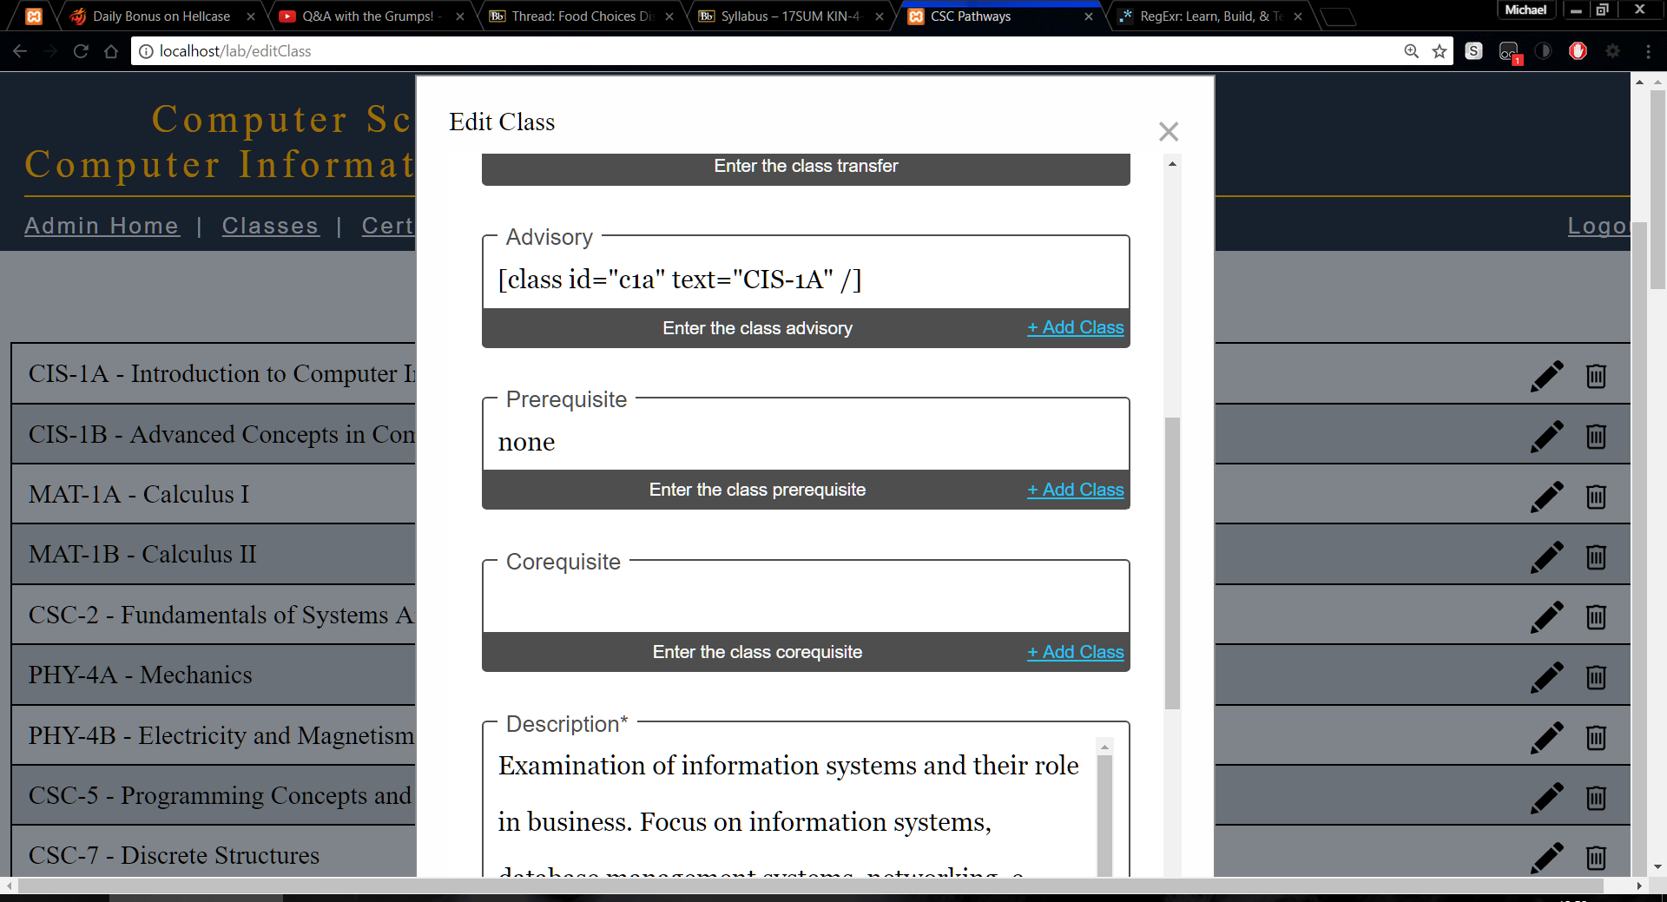

Figure 15 Showing the add class link in the create class form

After adding a class, you will see in Figure 15 that the text “[class id="c1a" text="CIS-1A" /]” has been added. This code will make a link with whatever text is inside of the quotes in text=”Cis-1A” if you wanted to add a * to make a note you would edit the text inside the quotes of text to text=”Cis-1A*”. Along with adding a class you can also add plain text as seen in the prerequisite field in Figure 15. These fields are optional.

#### Description

Description is where the class’s description is added this field will grow as you type. This field is required.

When you have filled in all the fields that are required and any optional fields you can click on save. It will then confirm that it has

### Possible problems creating a class

Fields are glowing red and no error modal was displayed as shown in Figure 16. This is because the field is a required field and it was left blank

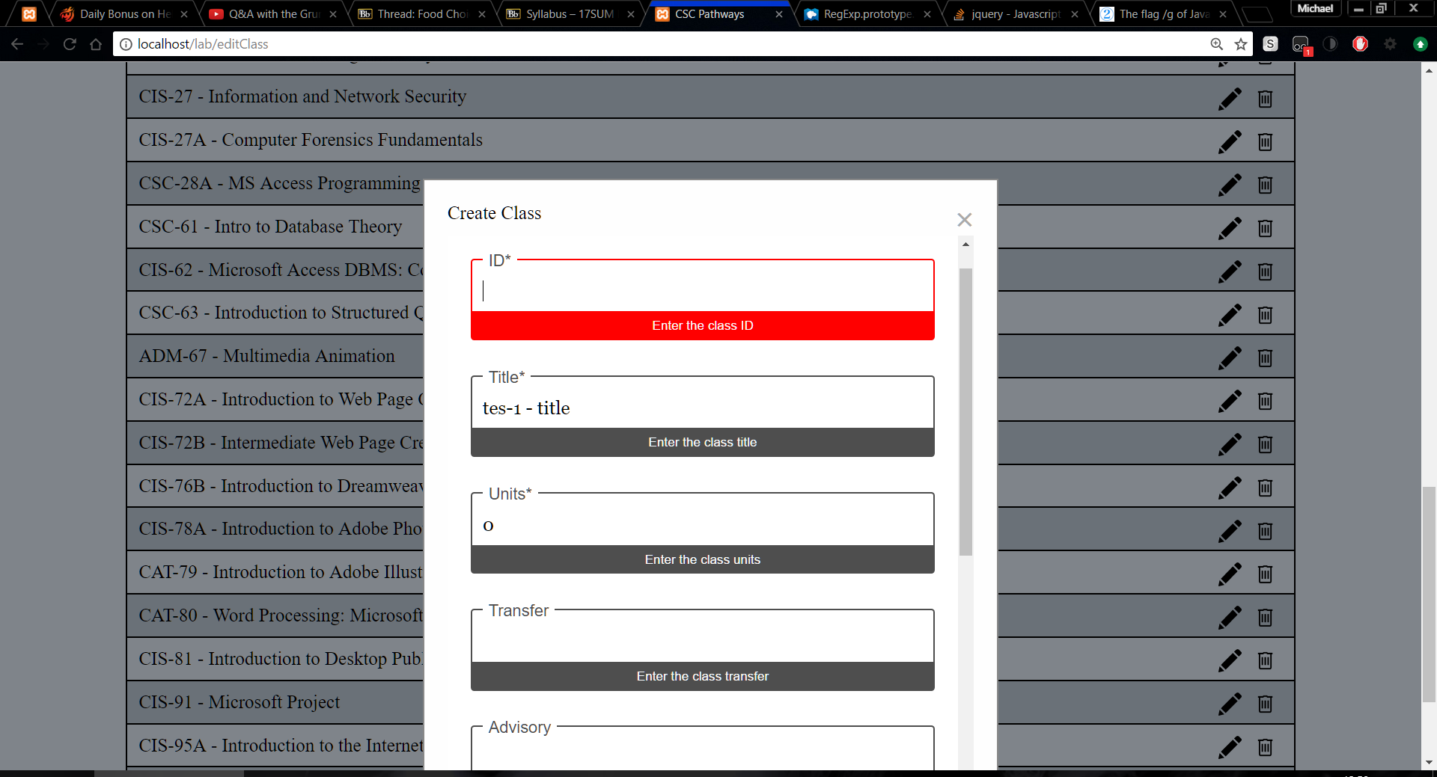

Figure 16 Displaying an error of glowing red fields

## Editing classes

Editing classes can be done from the classes link under the logo. Here you should see a listing of every class, at the far right of each class there is a pencil, globalization icon, and a trashcan icon. Click the pencil to edit the class.

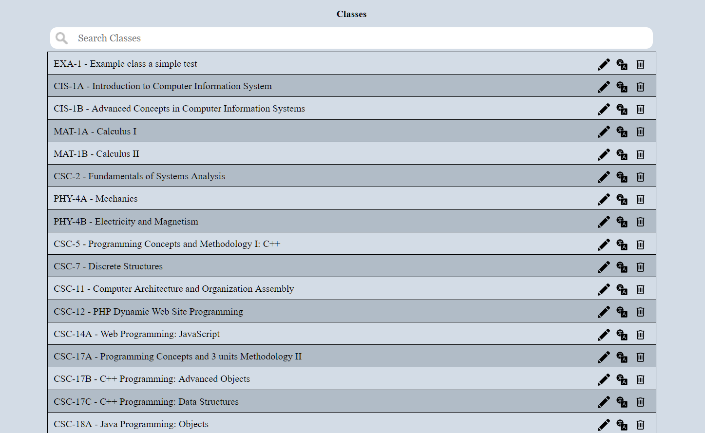

Figure 17 Listing of classes showing the edit, globalization, trashcan icon

Editing the class is the exact same as creating a class with the exception that you cannot change the ID. For more information on the fields review the create class section here.

## Deleting classes

Deleting classes can be done from the classes link under the logo. Here you should see a listing of every class, at the far right of each class there is a pencil and a trashcan icon. Click the trashcan to delete the class. Refer to Figure 17. The website will ask you if you are sure since once this is done it cannot be un-done.

# Managing Certificates

All the Certificates that appear in the certification information box and in the three boxes at the top of the page can be edited through the administrative side of the site. Managing certificates can be accessed by the link tilted certificates under the orange title. Below is a picture of all the editable areas for a certificate highlighted in red and the field names

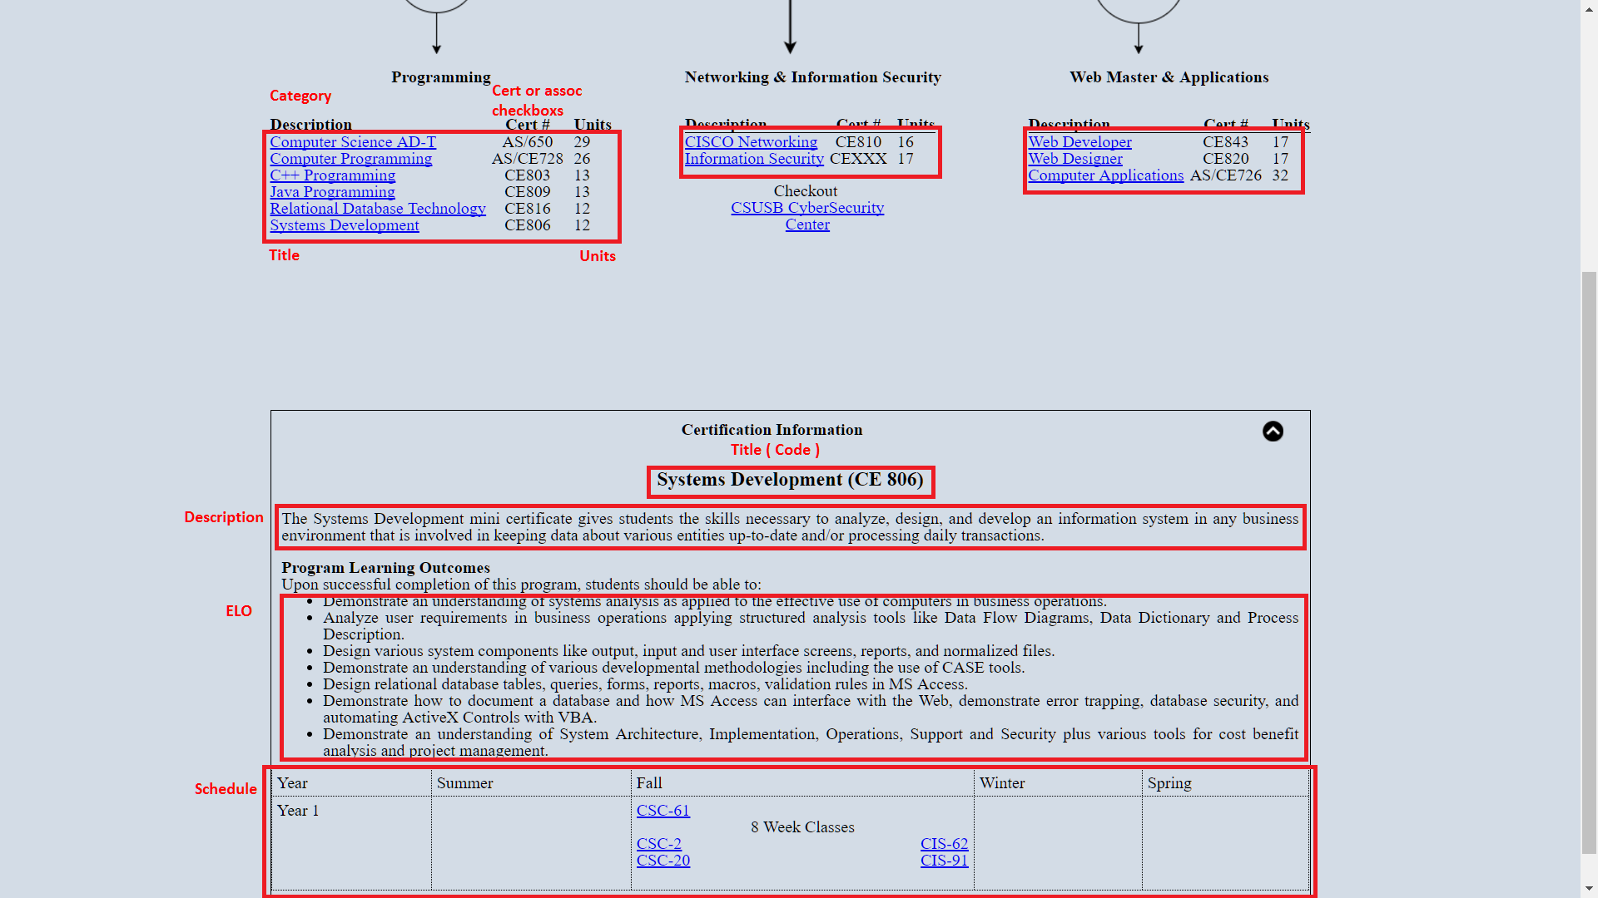

Figure 19 Showing all the editable areas of a certificate

## Creating certificates

To create a certificate in the manage certificate page, scroll down to the bottom of the page, and click the blue create certificate button

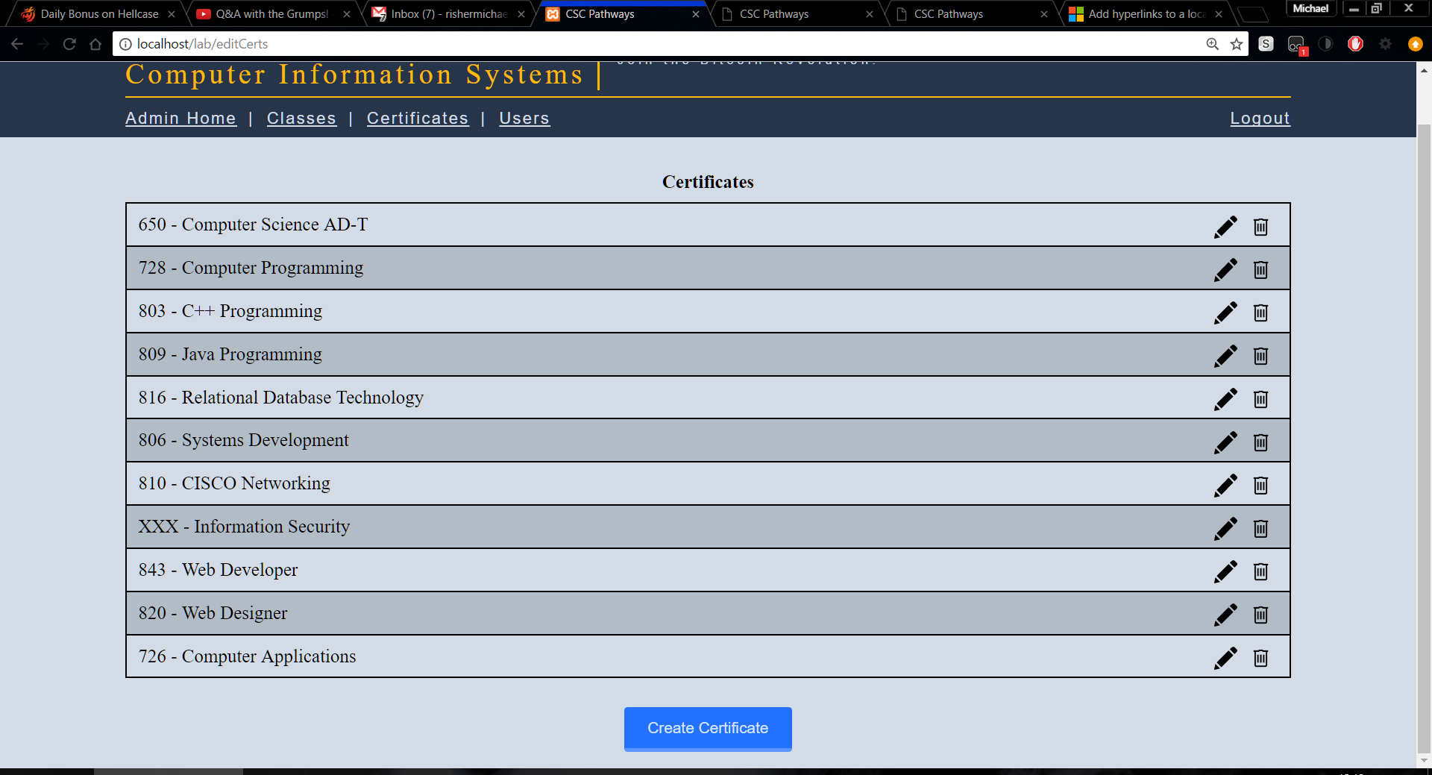

Figure 20 Showing the create certificate button

After clicking the create certificate button you will then be redirected to a different page to edit this, instead of a modal like the classes. You will arrive at a page that looks like this. This page contains all the editable fields for every certificate

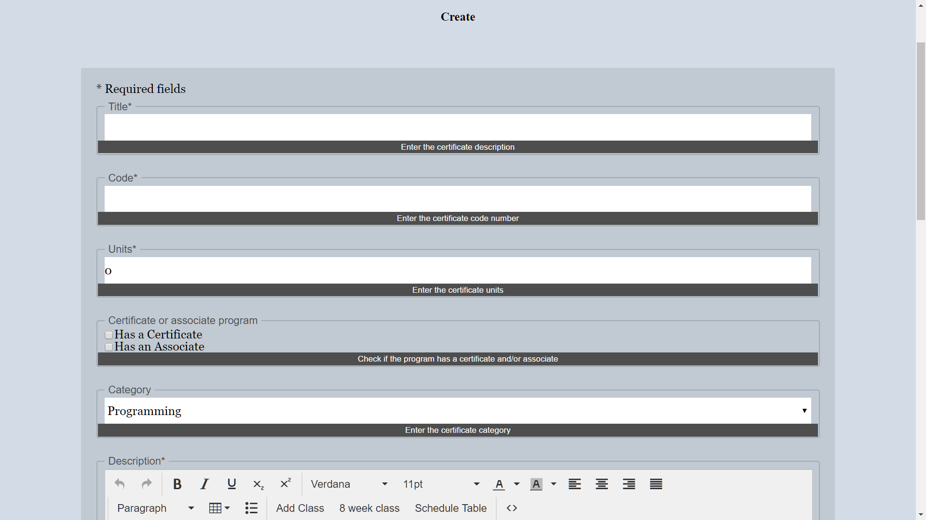

Figure 21 Illustrating the certificate edit form

There are six required fields in this form they are title, code, units, description, expected learning outcomes (ELO), schedule. These six fields must have a value and units can only be a number. All other fields are optional and can be left blank. Now to explain each of the fields

### Fields within the create certificate

#### Title

The title is the certificate’s name for example “Computer Programming”

#### Code

The code is a three-digit number that the certificate is identified by. For example, Computer Programming’s certificate code is 728.

#### Units

The units field is the number of units needed to take, to receive the certificate. For example, Computer Programming’s certificate units is 26.

#### Certificate or Associate program

The certificate or associate program consists of two checkboxes. These checkboxes determine whether this certificate is an associate degree and/or a certificate. On the user homepage, this will change how the code is displayed. If you only check the certificate checkbox it would look like CE728. If you were to check the associate instead of certificate it would look like AS728. If you checked both checkboxes it would look like AS/CE728.

#### Category

The category is there to place this certificate on the homepage. There are three categories which are for the three areas under the flowchart on the user homepage. These categories are: programming, networking, and web master. This field will default to programming if not set.

#### Description

The description is the first field that allows rich text. Meaning that you get an advanced text editor that allows for various style changes. The description is the description of the certificate. For example, Computer Programming’s certificate description is “This program focuses on the general writing and implementation of generic and customized programs…”

#### Expected learning outcome (ELO)

The ELO is a list of expected learning outcomes for the certificate. To create a list in the editor you will want to click on the button that is enclosed in the red box in Figure 21.

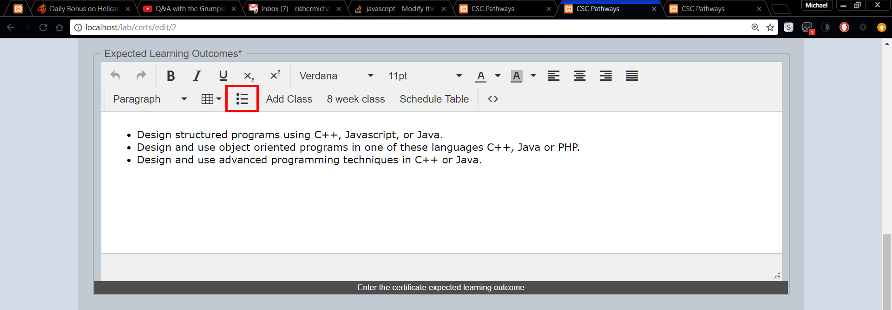

Figure 22 Depicting the icon to create a list

#### Schedule

The schedule is the outline of classes you need to take and when to take them. This is the most complicated field to edit. I will walk you through it here. First off you want to click on Schedule Table which you can see in the enclosed red box in Figure 22

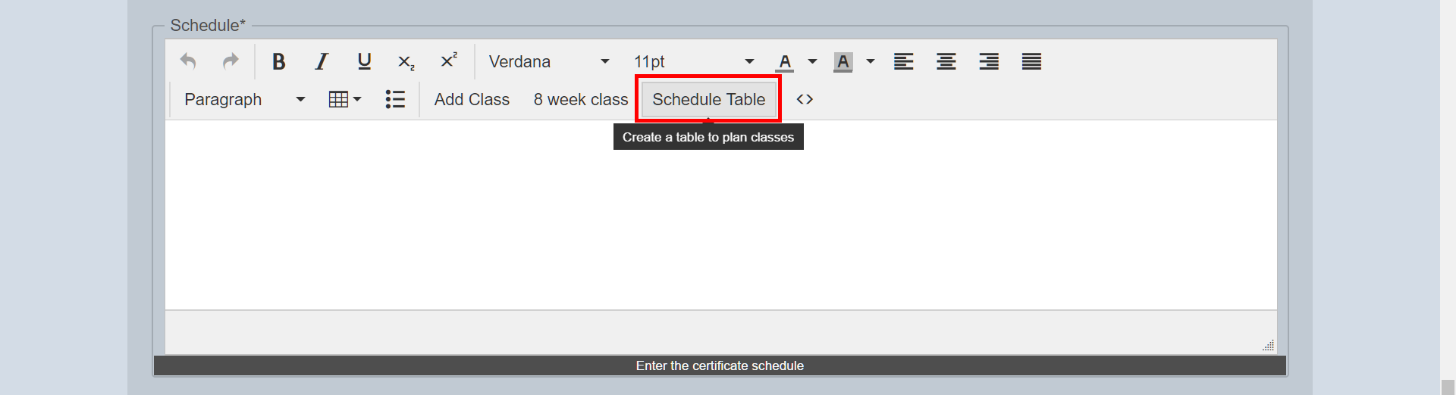

Figure 23 Showing the schedule table

After you click the Schedule Table button you can see a small table with all four semesters and a blank row with only year 1. Let’s create a class in the summer row for year 1. You want to remove any spaces in the blank spot. Then click on the Add Class button which you can see enclosed in a red box in Figure 23

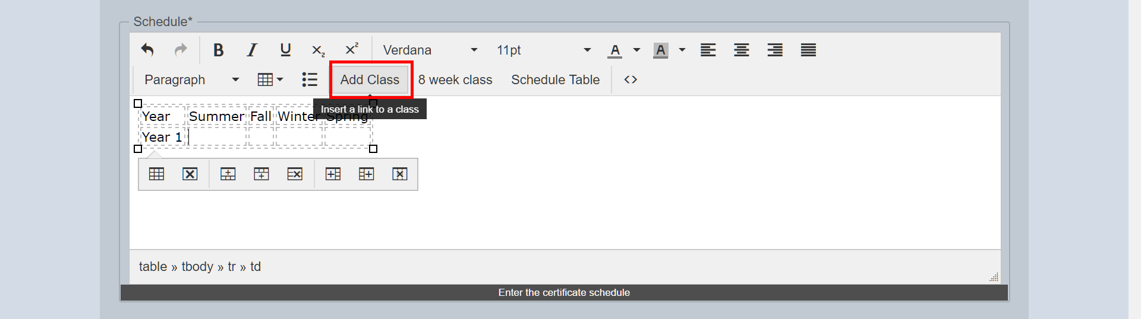

Figure 24 Depicting the Add Class button

After clicking the Add Class button a modal should popup with a dropdown of classes. Pick the class you want and click the add button at the bottom of the modal.

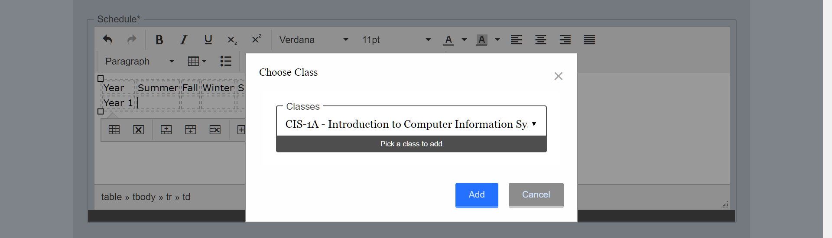

Figure 25 The Add Class button displaying a choose class modal

After clicking add you should see some text appeared where you were typing in the editor. It should look something like this [class id="c1a" text="CIS-1A" /]. That text will create a link on the user homepage to go to that class. If you wanted to add a superscript to that link you could go inside the quote where text= and after the A and type your superscript letter or number. Then highlight that letter or number and click the superscript button which looks like X2. To add an 8-week class, go to the end of the current line a make a new line. Then hit the 8 Week Class button which you can see enclosed in a red box in Figure 25

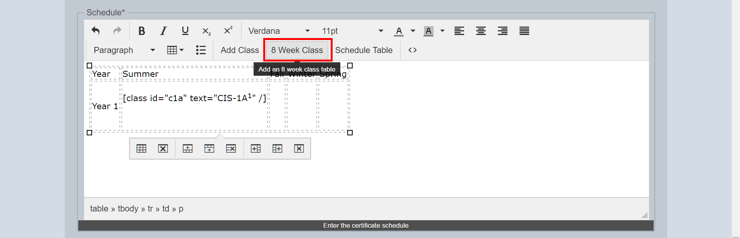

Figure 26 Depicting the 8 Week Class button

After clicking the 8 Week Class button you will see that another table is now inside the cell you were editing. In this smaller table, there is two cells with the text class1 and class2. You can highlight that text and replace it with a class from the Add Class button.

#### Position in list

The position in the list is where this certificate should be listed on the user homepage for its category. The counting scheme starts at zero. Zero means it is the first item displayed. A value of one will be below the item which has a value of zero.

### Possible Errors

#### Fields glowing red

Fields are glowing red as shown in Figure 26. This is because the field is a required field and it was left blank.

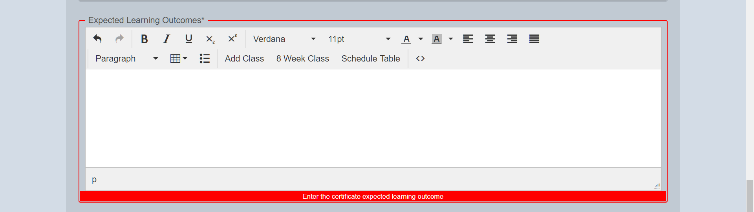

Figure 27 Showing the glowing error

#### Table is to small on user homepage

If the table is too small on the user homepage which can be seen in Figure 27

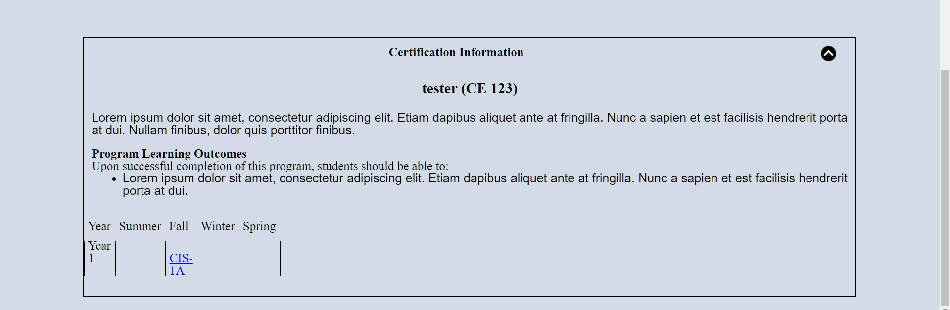

Figure 28 Showing a table that is to small

To fix this edit the certificate and go to the schedule field. Click anywhere inside the table within the editor. A menu should appear within the editor. Click on the first button which should be table properties in this menu as seen in Figure 28

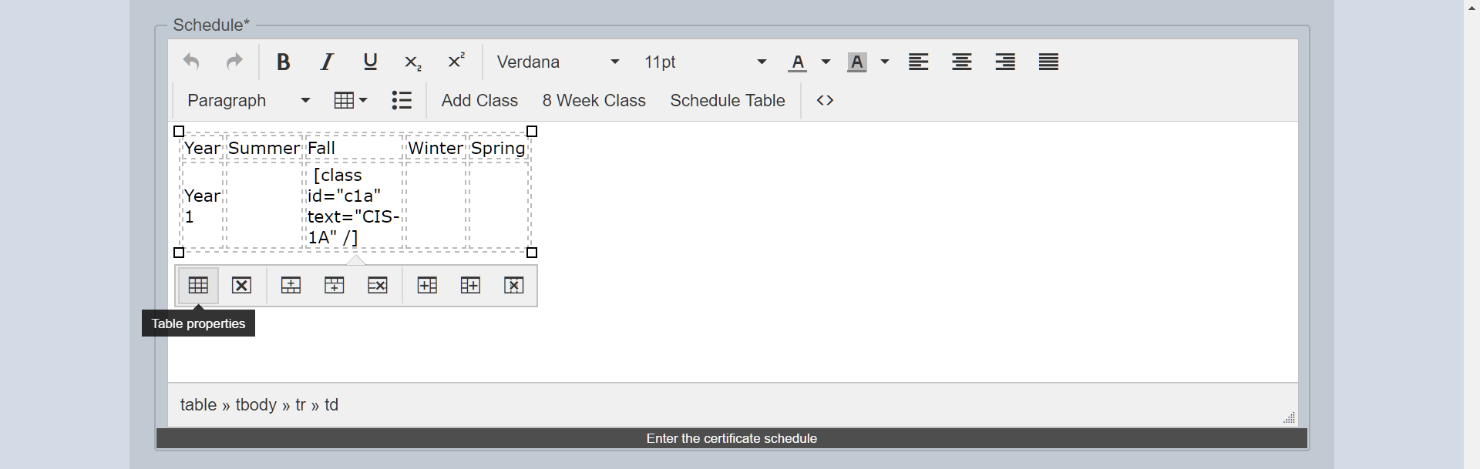

Figure 29 Table menu showing the table properties

After clicking the table properties button, you will see a modal popup showing the width, height, and various other options. If the table is to small there is a number in the width or height fields which you can see in Figure 29.

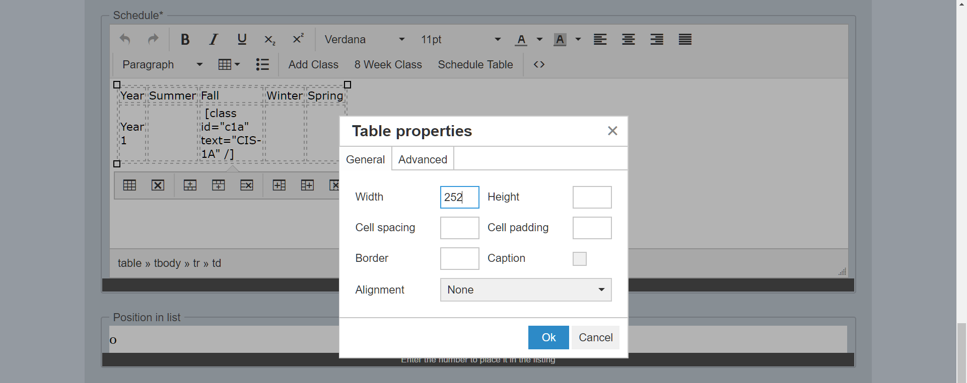

Figure 30 Table properties modal

To fix this simply erase the number in either the width field or height field.

## Editing certificates

Editing certificates can be done from the certificates link under the logo. Here you should see a listing of every certificate, at the far right of each certificate there is a pencil and a trashcan icon. Click the pencil to edit the certificate.

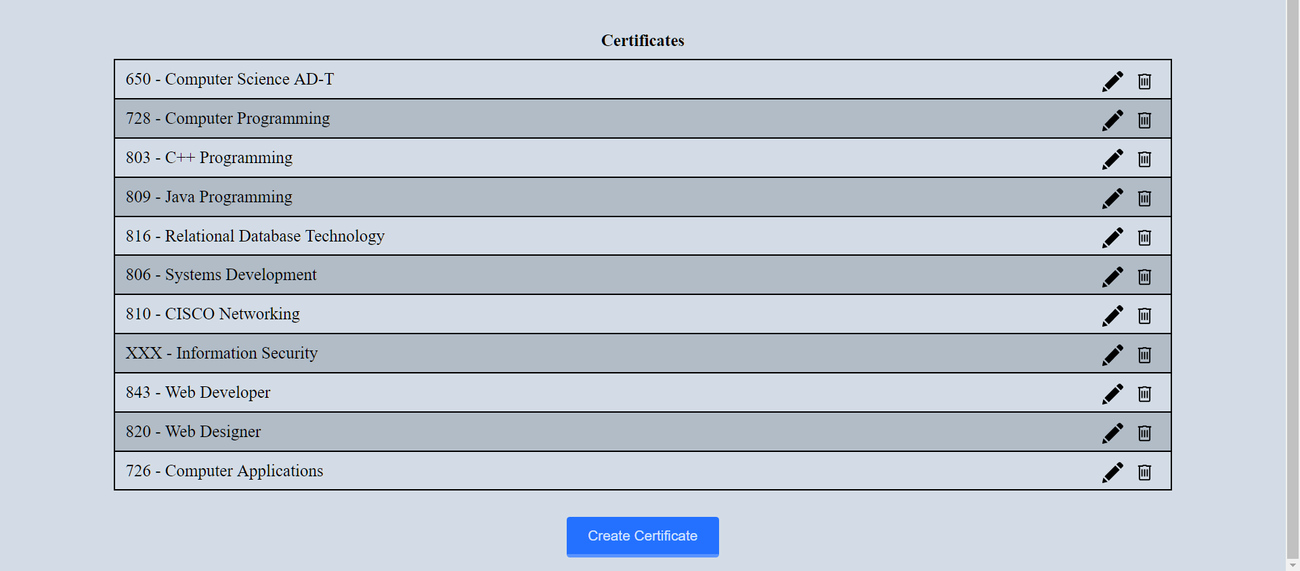

Figure 31 Listing of certificates showing the edit and trashcan icon

Editing the certificate is the exact same as creating a certificate. For more information on the fields review the create certificate section here.

## Deleting certificates

Deleting certificates can be done from the certificates link under the logo. Here you should see a listing of every certificate, at the far right of each certificate there is a pencil and a trashcan icon. Click the trashcan to edit the certificate. Refer to Figure 30. The website will ask you if you are sure since once this is done it cannot be un-done.

# Managing Users

Only administrator users can manage other users. Manage users can be access by the link title users under the orange title.

## Creating users

If you are an administrator user you can create a user by scrolling to the bottom of the mange user page and clicking the create user button. This will open a create user modal.

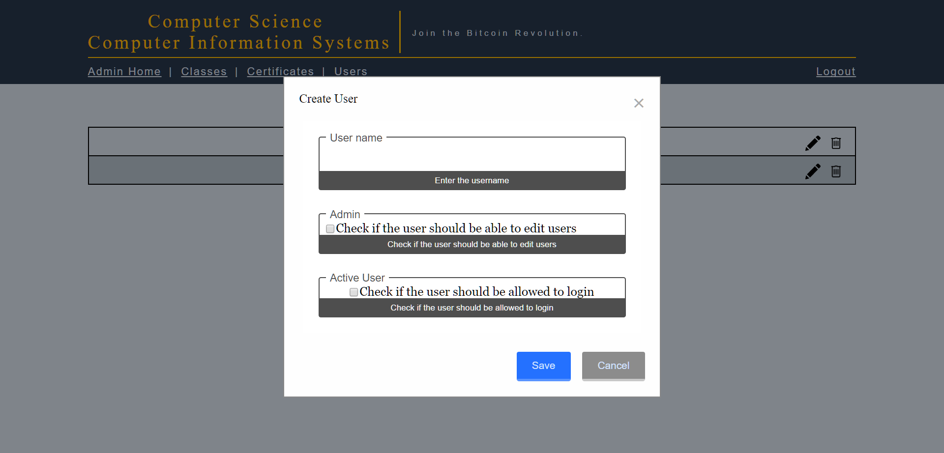

Figure 32 The create user modal. Usernames have been omitted in the background.

After clicking the create user button the create user modal will appear. In this form, you need to fill out the username for the user. You make this user an administrative user if you wish. In the active user area, you need to check the checkbox if you want the user to be able to log in. Without that checked the user will not be able to log in. When you are done click the save button.

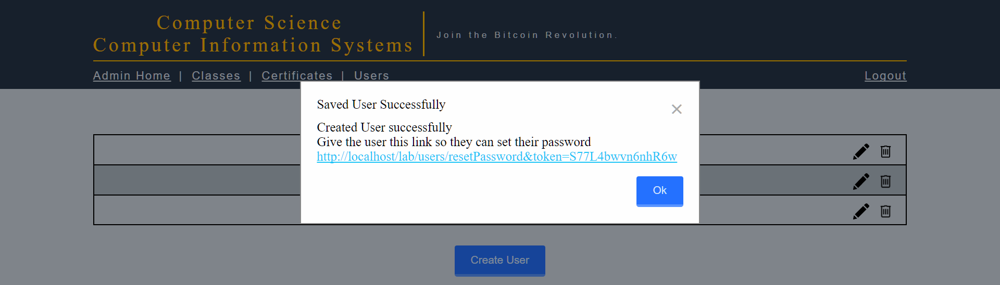

Figure 33 After creating a new user, a recover password link appears. Usernames have been omitted in the background.

After clicking the save button a modal will pop up with a link this link is very important. This link is what you give the user to set their password. If you clicked Ok without copying this link you can go to Recovering a password for a user to make them a new link.

## Editing a user

Editing users can be done from the users link under the logo if the user is an administrator. Here you should see a listing of every user, at the far right of each user there is a pencil and a trashcan icon. Click the pencil to edit the user.

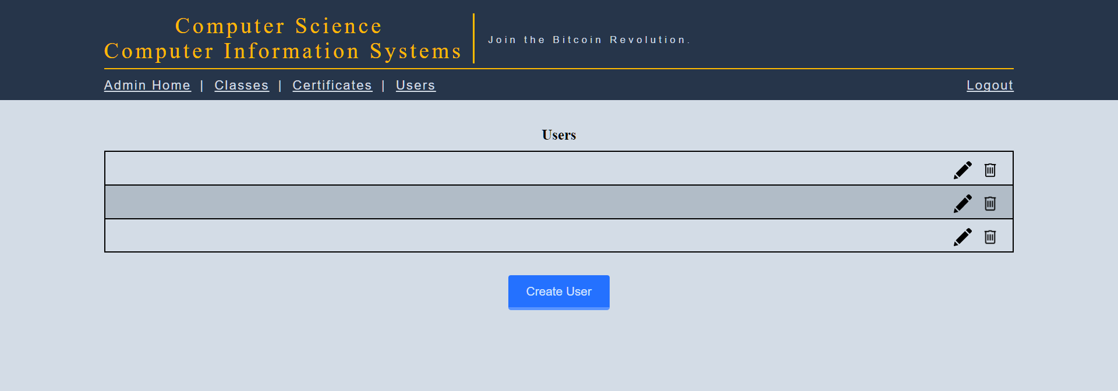

Figure 34 The user listing with the edit and delete icons. Usernames have been omitted but would show.

Editing the user is the exact same as creating a user except there is a recover password button. For more information, how to create a user see the Creating user section.

## Recovering a password for a user

Since the administrator cannot interact in any way with the user’s passwords a recover password link must be created if a user forgets or loses their password. To recover a password the administrator must edit the user and click the Reset Password button at the bottom.

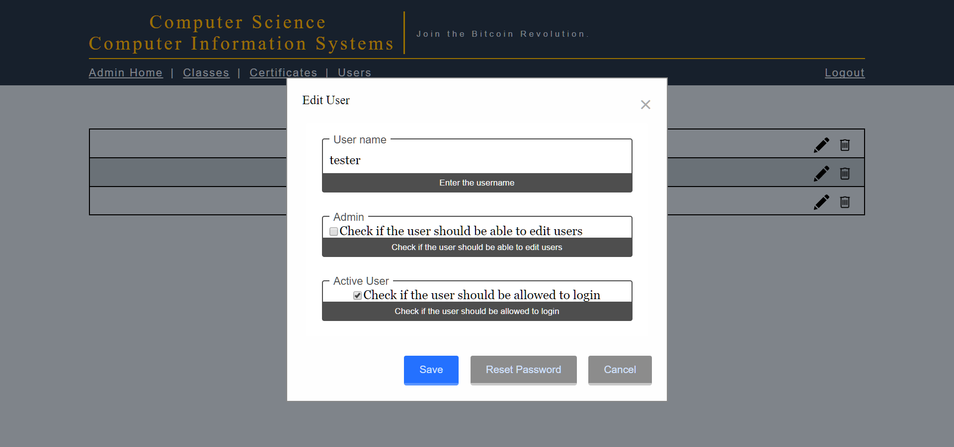

Figure 35 Reset password button shown on the bottom. Usernames omitted in the background.

After clicking the reset password, you will see this modal. Make sure to copy the blue link and give that to the user.

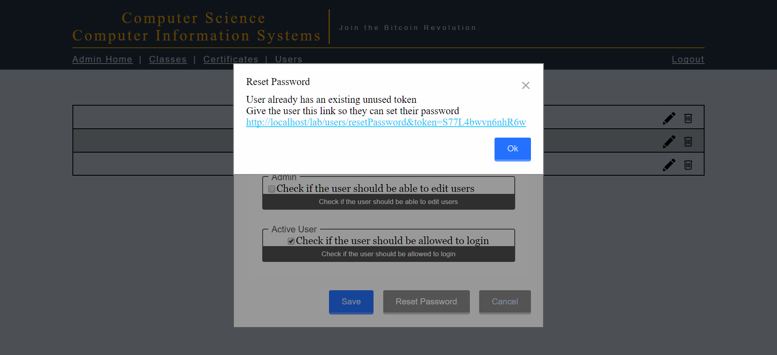

Figure 36 Showing the recovering password for a user

If a link already exists for the user it will use that one instead of creating a new link as it did here.

## Deleting a user

Deleting users can be done from the users link under the logo. Here you should see a listing of every user, at the far right of each user there is a pencil and a trashcan icon. Click the trashcan to delete the user. Refer to Figure 32. The website will ask you if you are sure since once this is done it cannot be un-done.